***P2***

***Operating Systems***

* What is it?
* What/how it performs/functions

An operating systems means it is like a backbone to the computer. It provides support to a computer’s basic functions, such as controlling peripherals. This is important because an application usually requires an operating system to function. Therefore, the purpose of having an operating system is that without an operating system, it will not work. It is like a backbone to the computer and if it doesn’t have that, it will not work. An operating system functions by controlling the peripherals, starts the computer, manages programs, security for the computer e.g. password, manages the memory, accessing the web and controls the web.

**Starting up computer**

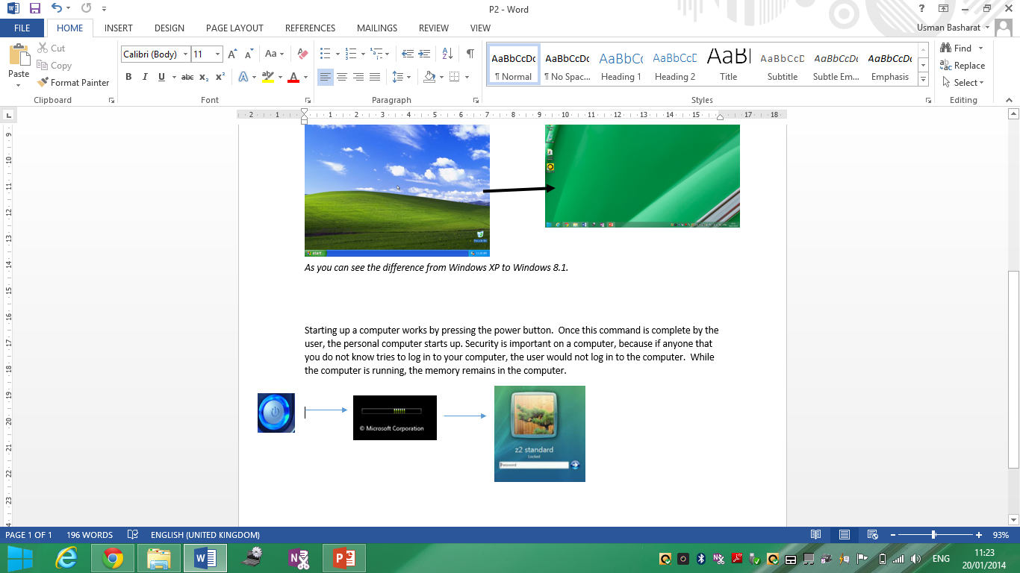Starting up a computer works by pressing the power button. Once the user has pressed the button, it sends out signals to the components. The BIO does a quick test if the components are working. The *kernel* and the system files loads it into the memory. Once this is complete, the operating system will work. Kernel means while the computer is running, the memory remains in the computer. This means that any document that is running will stay in the memory of the computer, but it has to be saved to stay permanent. Security is important on a computer, because if anyone that you do not know tries to log in to your computer, the user would not log in to the computer. When shutting the computer, they are different types of booting. Booting is the process of starting or restarting the computer; warm boot is when the computer is restarted whilst the computer is powered on. If any documents are unsaved, it will not be saved.

**Memory**

The operating system manages the memory by organising, instructing and allocates to an area of memory. When the operating system manages the memory, it can two tasks that it needs to be aware of:

* Each processor must have enough memory
* The different types of memory must be used properly so that it can be run by the processor

If the memory doesn’t have enough memory left, the operating system uses the *virtual memory.* The virtual memory combines the RAM left with the virtual memory by moving the RAM files to the virtual memory. The more RAM you have, the faster the programmes will run.

**Providing a user interface**

User interface could be addressed as UI as this means it is a part of a software where the user controls the software application. Most of the operating system use some of these interfaces. They are three types of user interfaces:

* Graphical
* Command-line
* Menu-drive

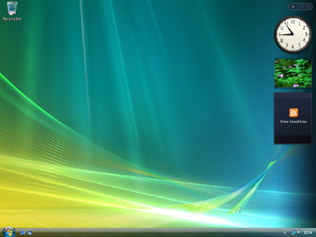**Graphical user interface** (GUI) is when a user chooses an icon by using its mouse. For example, ‘drag’ and ‘drop box on the desktop. As the image on the right shows an example of where graphical user interface could be used.

**[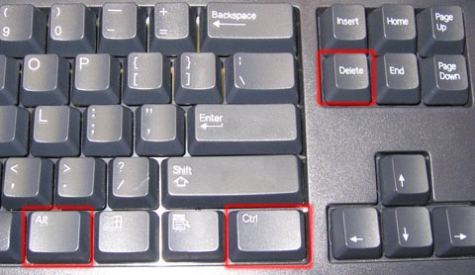](http://www.google.co.uk/url?sa=i&rct=j&q=&esrc=s&frm=1&source=images&cd=&cad=rja&docid=zspRNYH17oPxiM&tbnid=JxNdt3z8j0CIGM:&ved=0CAUQjRw&url=http://blog.mightyuninstaller.com/remove-playtopus-how-to-completely-delete-adware-playtopus/&ei=aDXdUumoNuST0QWX8oDYBA&bvm=bv.59568121,d.ZG4&psig=AFQjCNH_KSP3vcYwUxmqEz4qXMTpdku1yg&ust=1390315230420598)**

**Command-line** is one where the user enters a command. A keyboard command where the user presses altogether so the computer understands what it is. For example ALT, CONTROL and DELETE. CTRL C is a special key where it copies and CTRL V is where it pastes the text.

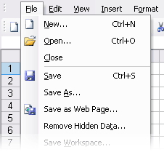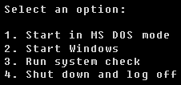**Menu-drive** is given a command by a menu. As this image givens the user an option. This is a simple menu. They can be a full menu which takes up the whole screen. A menu bar is a set of drop-down options. They are user-friendly and easy to use as they do not need to be remembered.

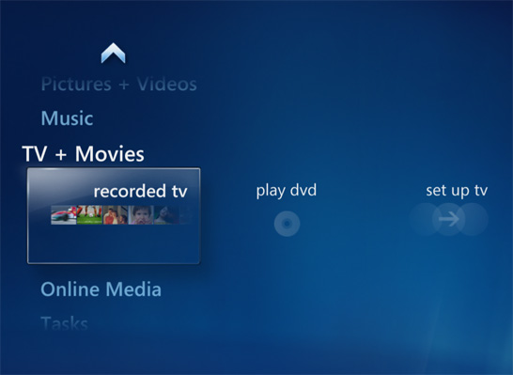

*All of these types that have been mentioned are controlled by the operating systems.*

**Programmes and Printers**

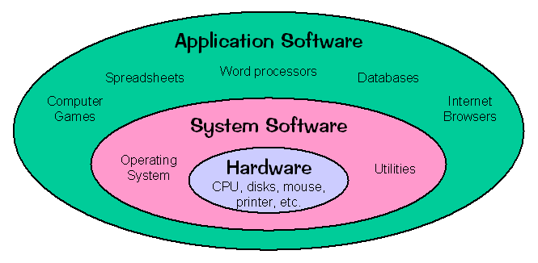The operating system manages the programmes that have been installed into the computer. It manages to do this as the operating system can multitask- complete more than one command at the same time. It also manages to have send singles to the computer, therefore once the user printed the document, the operating system sends a signal to the printer to complete that command. Referring to this image, it tells us that the core is the hardware and then it is the operating system. Therefore, operating system manages all the application softwares that they have on the computer.